Train and deploy on-device image classification model with AutoML Vision in ML Kit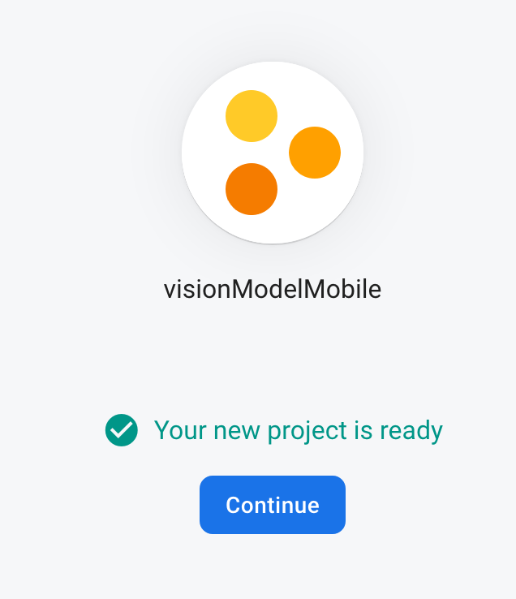

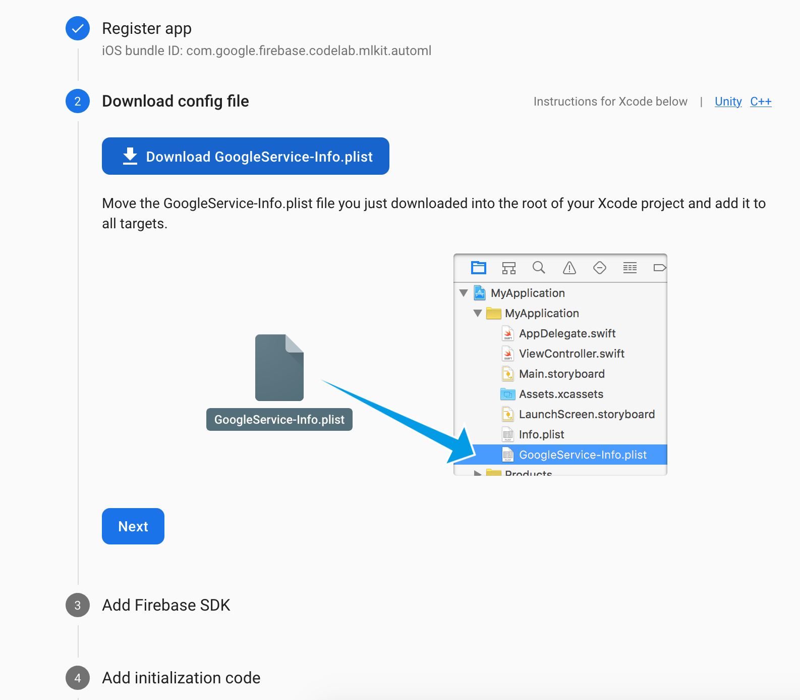

Install cocoapods on mac:

sudo xcrun gem install cocoapods

Create a dataset and import flower_photos.zip to it.

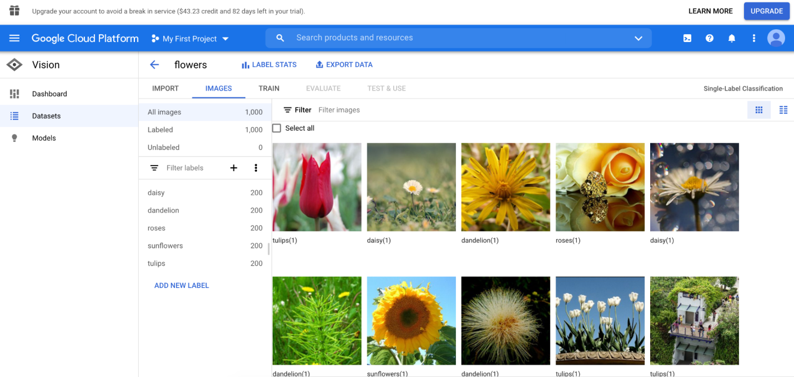

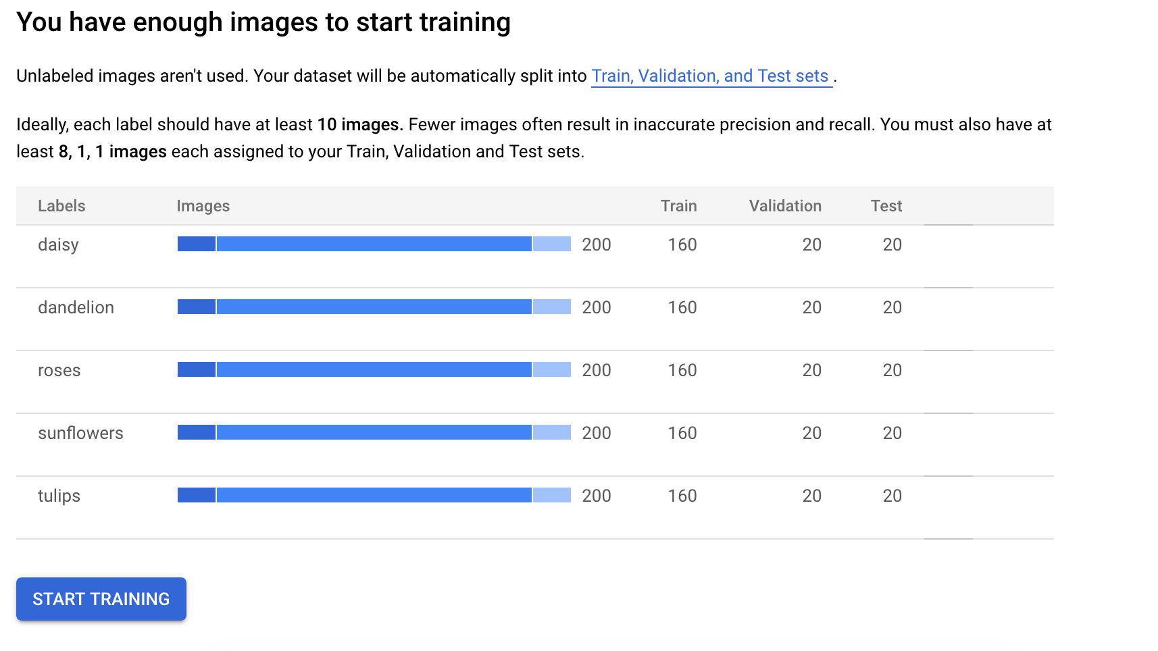

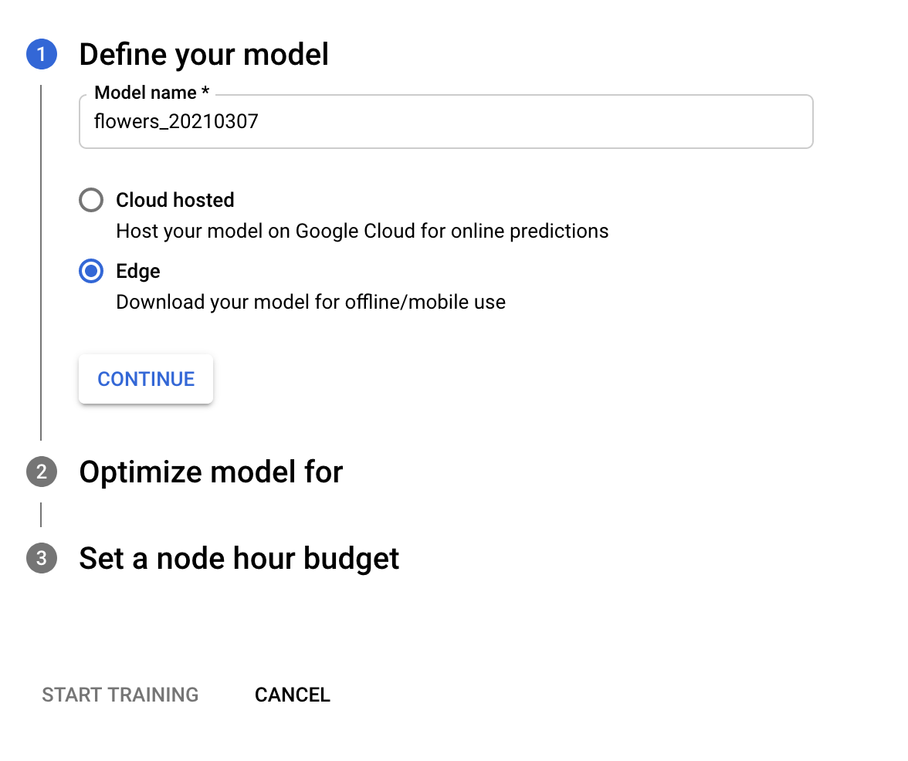

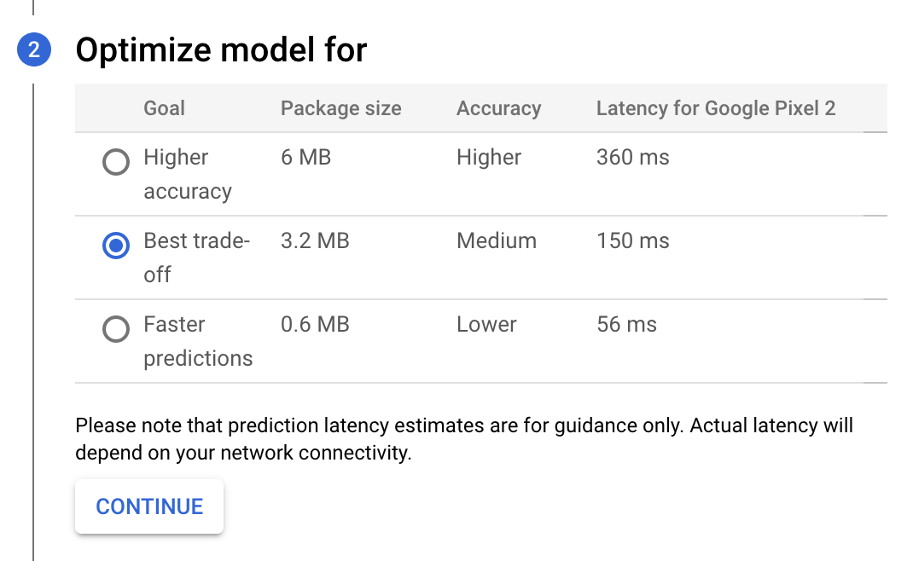

## Download image classification model after training

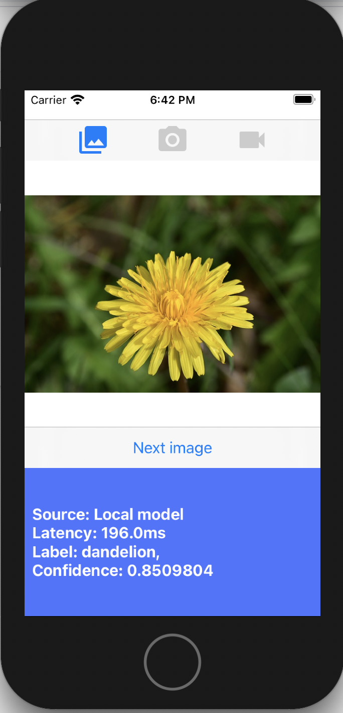

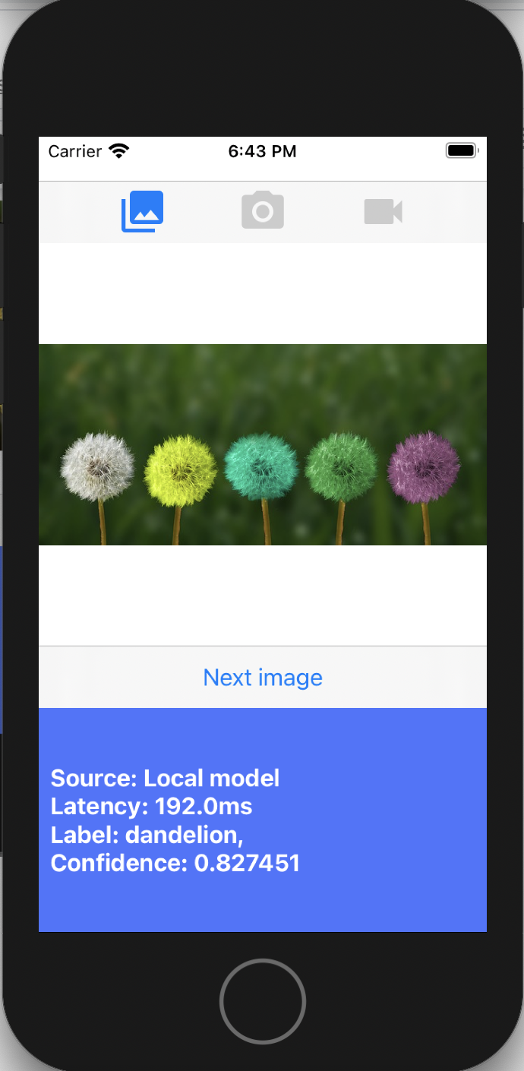

Conclusion

I have gone through an end-to-end journey of training an image classification model with the training data using AutoML, and then use the model in a mobile app using ML Kit.

Time Series Forecasting with the Cloud AI Platform and BQML

Create a new instance, select the latest TensorFlow Enterprise 2.x instance type without GPUs:

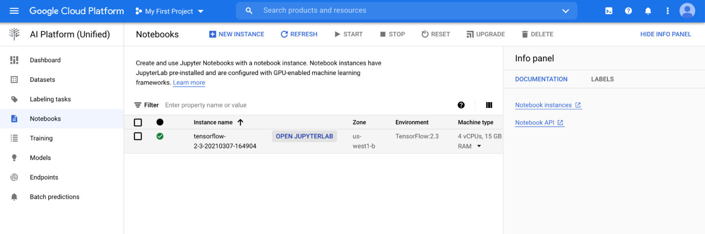

Create a **Python 3** notebook from JupyterLab:

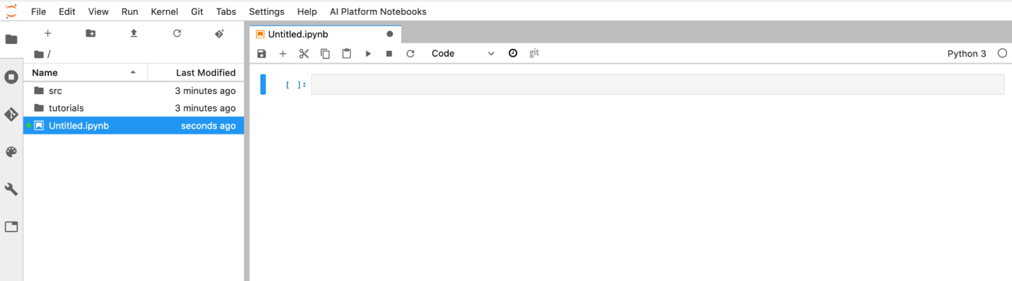

## **Download lab materials**

* Create a new Terminal window from the JupyterLab interface: File -> New -> Terminal.
* From there, clone the source material with this command:
* Create a new terminal, File -> New -> Terminal

And clone the code from github:

git clone https://github.com/GoogleCloudPlatform/training-data-analyst

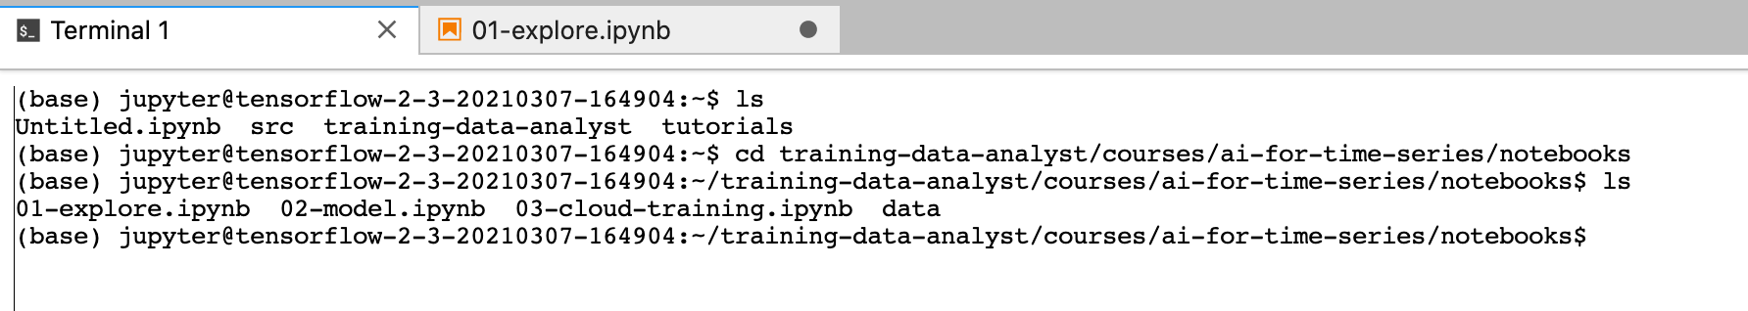

## 

Step 1: In AI Platform Notebook, navigate to training-data-analyst/courses/ai-for-time-series/notebooks and open 01-explore.ipynb.

Step 2: Clear all the cells in the notebook (Edit > Clear All Outputs), change the region, project and bucket settings in one of the first few cells, and then Run the cells one by one.

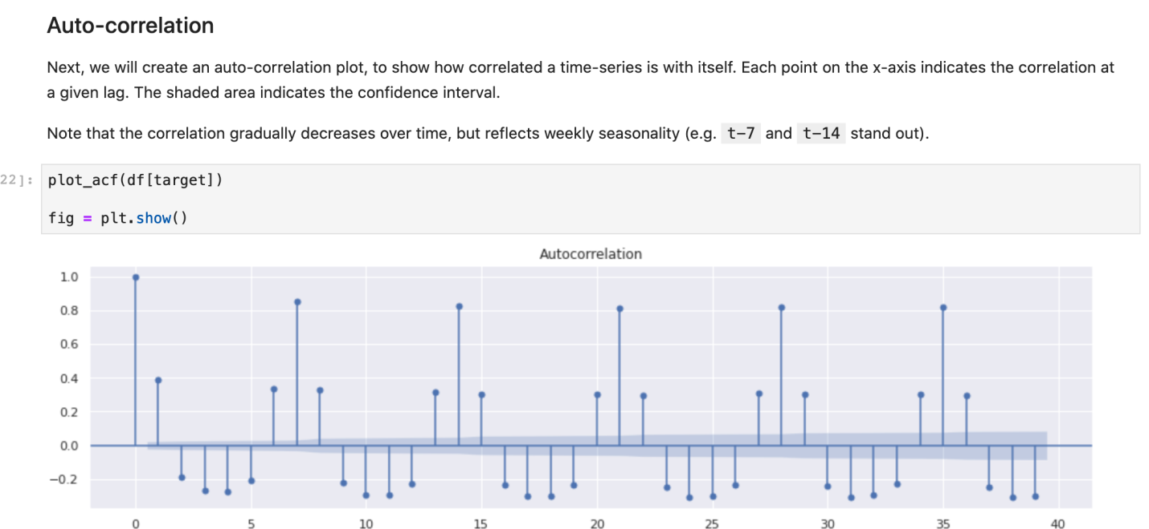

## **Create a Model with BigQuery Time Series Forecasting**

Step 1: Create table with: https://github.com/GoogleCloudPlatform/training-data-analyst

training-data-analyst/courses/ai-for-time-series/notebooks/data/cta_ridership.csv

Step 2:

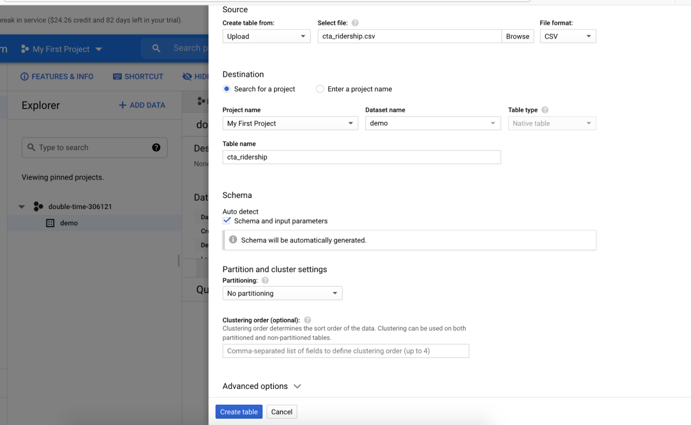

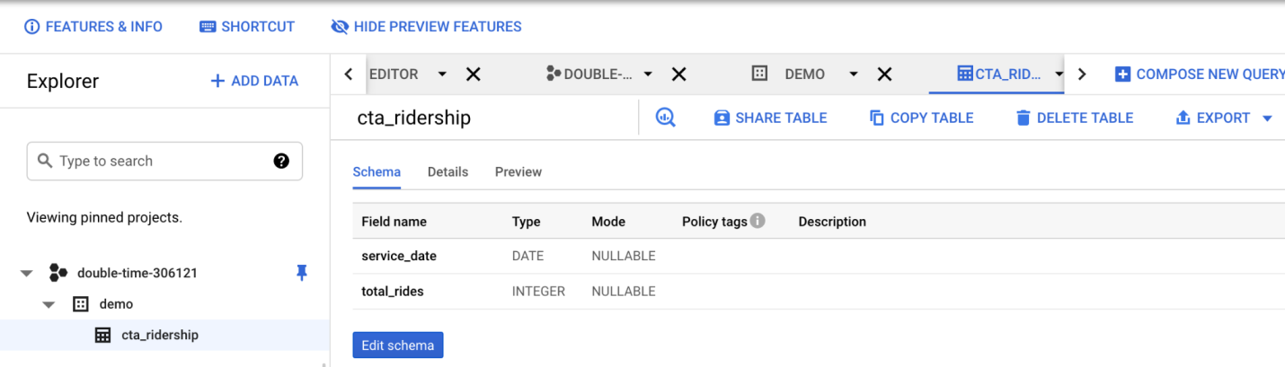

Step 3: Create a model

Put below in query editor:  
CREATE OR REPLACE MODEL

`demo.cta_ridership_model` OPTIONS(MODEL_TYPE='ARIMA',

TIME_SERIES_TIMESTAMP_COL='service_date',

TIME_SERIES_DATA_COL='total_rides',

HOLIDAY_REGION='us') AS

SELECT

service_date, total_rides

FROM

`demo.cta_ridership`

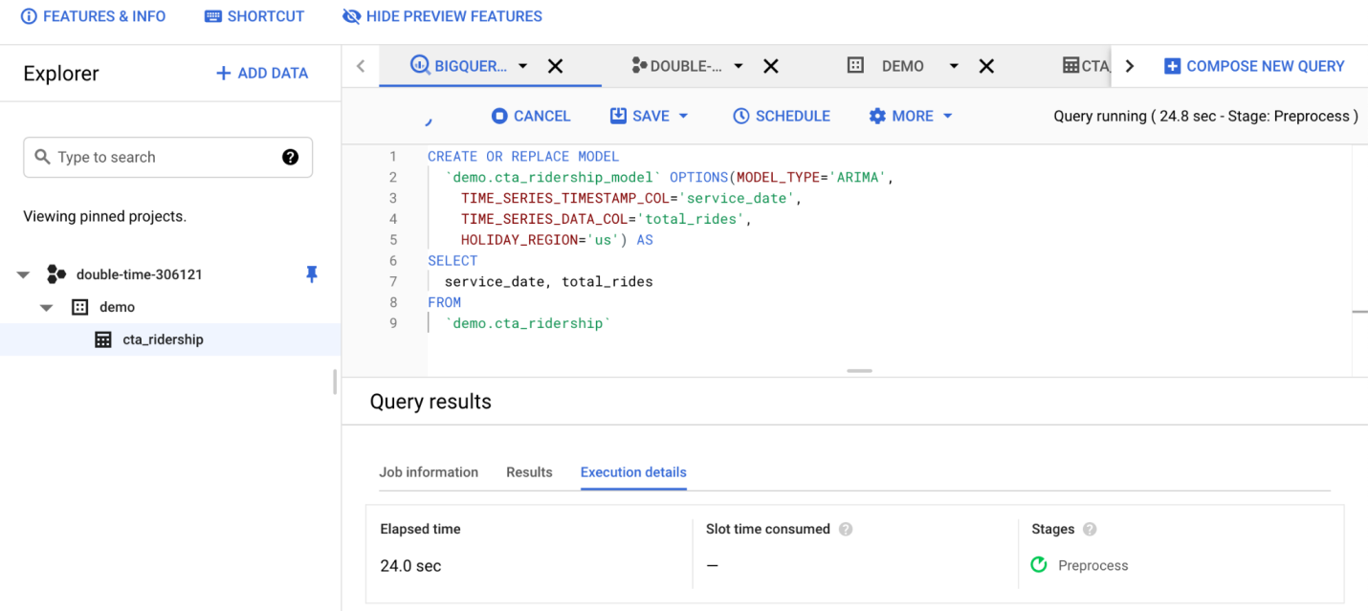

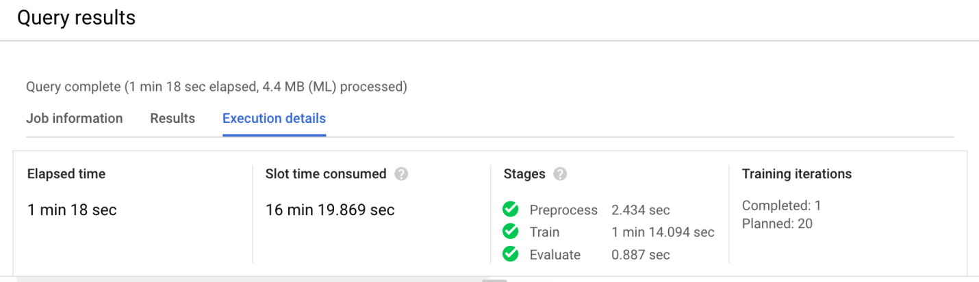

When it is finished, create a query to evaluate the model:

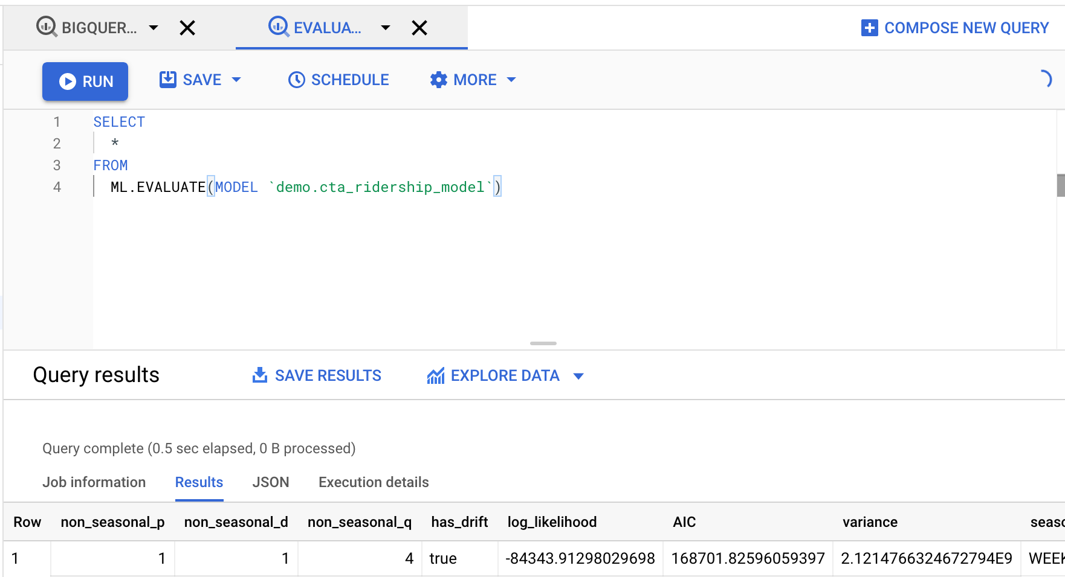

Create a query for forecast

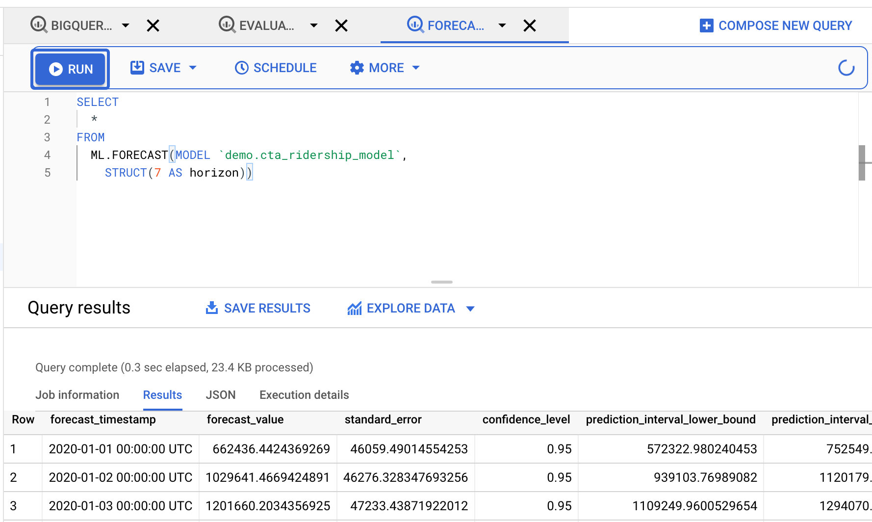

We have created a time series model with just a few BQML queries.

## **Build a Custom Forecasting Model**

### **Remove outliers**

### **Long Short Term Memory (LSTM)**

### **Convolutional Neural Network (CNN)**

### 

### **Naive Model****Seasonal Naive**

### 

### **Exponential Smoothing**

### 

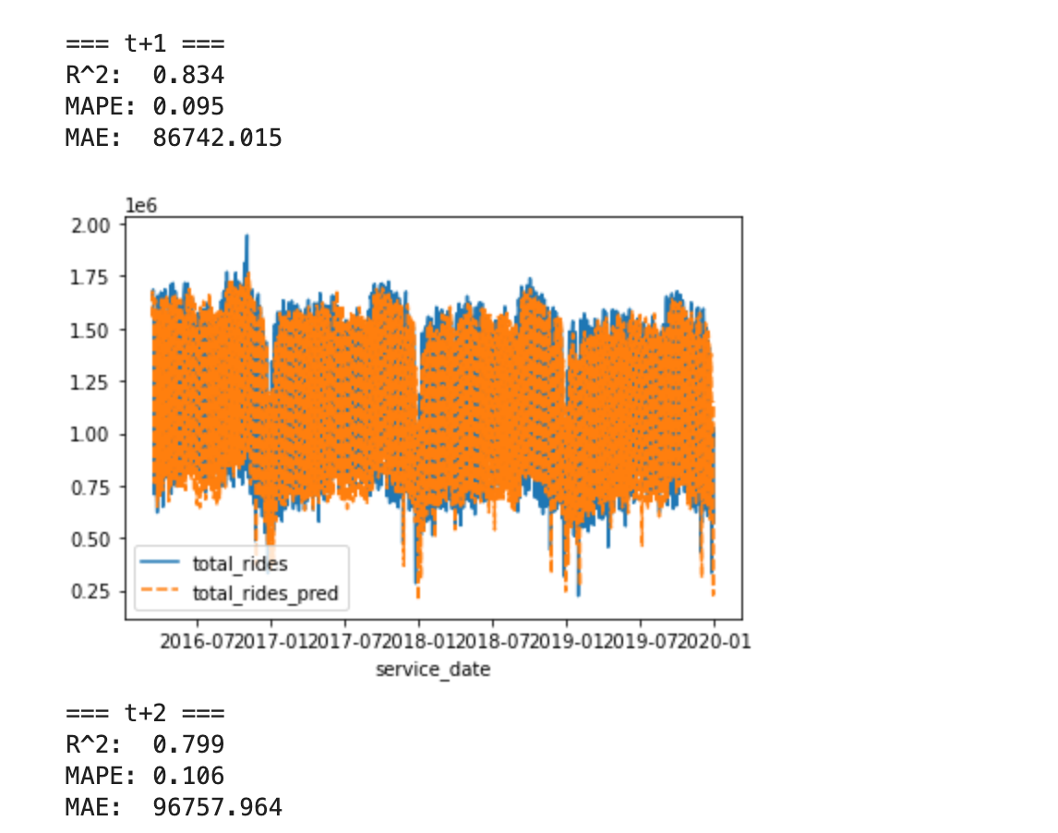

### 

### **Ensemble ML and Statistical Models**

### 

### 

## 

Predict

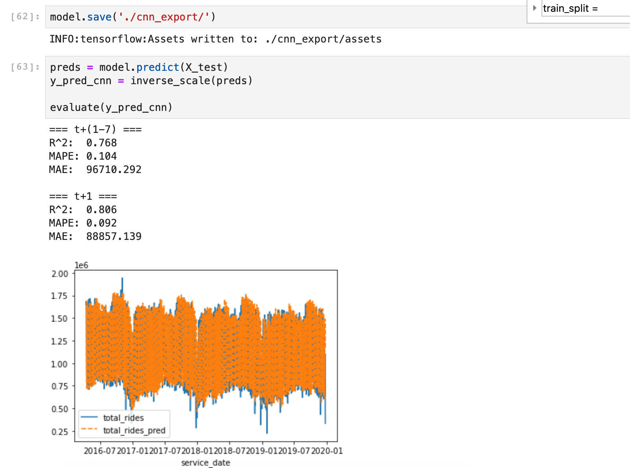

## **Naïve Models**

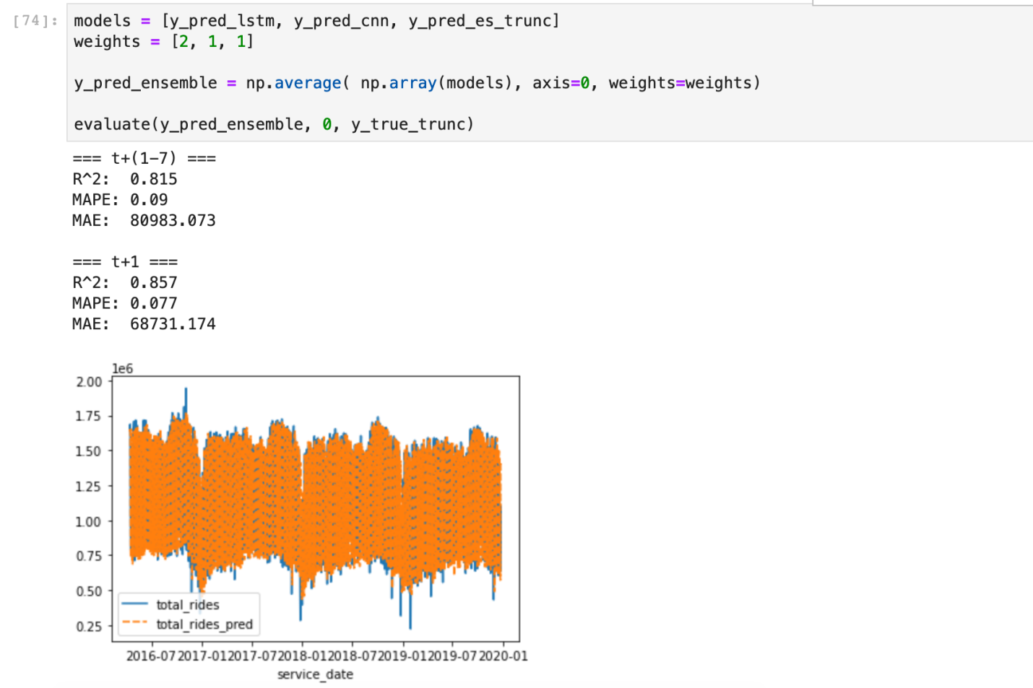

## **Train and Predict in the Cloud**

